Chapter 4, Solution 37

Find the Norton equivalent with respect to terminals a-b in the circuit shown in Fig. 4.104.

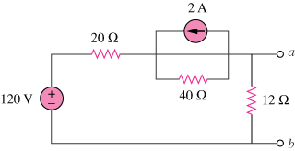

Figure 4.104
For Prob. 4.37.

Solution

R_{N} is found from the circuit below.
20
a

40
12

_{b}
10 Ω
I_{N} is found from the circuit below.

2A

20
a

+ 40
120V 12
- I_{N}

b

Applying source transformation to the current source yields the circuit below.

20 40 + 80 V -

+
120V I_{N}
-

Applying KVL to the loop yields
666.7 mA.

